**Library Management System**

**Name:** Prabhpreet Bhatia

**ID**: 1233816

**Abstract**

Library management system is a project which aims in developing a computerized system to maintain all the daily work of library. This project has many features which are generally not available in normal library management systems like facility of user login. It also has a facility of admin login through which the admin can monitor the whole system Overall this project is being developed to help the Library to maintain the library in the best way possible and also reduce the human efforts.

**INTRODUCTION**

**Features of library management**

* Manage Book and Member Record
* Add books and new members
* Update/Edit books and members
* Delete books and member
* Issue a book
* Data can be searched by entering Book name
* Shows number of pending books

**Needs of Library System**

* Improved customer service
* Increased productivity and job satisfaction
* More economical and safer
* Easier access to information
* Reduces error
* Greater accountability and transparency
* More reliable security

**Objectives of the system developed was aimed at**

* Improvement in control and performance
* Save cost
* Save time

**INFORMATION GATHERING**

Before setting up the system by software development tools, information will be gathered from the staff about the need for the users of the system like the staff of library and those readers by using qualitative gathering techniques (oral interviews)

**Problems of existing system**

* Loss of data
* Time wasting
* Error Prone
* Tedious
* Processing Speed

**System development life cycle**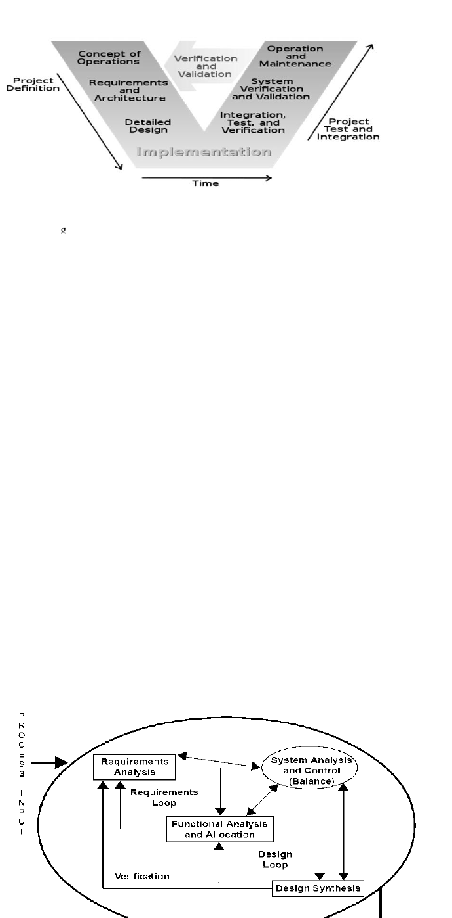

**The V model:** represents a software development process (also applicable to hardware development) which may be considered an extension of the waterfall model. Instead of moving down in a linear way, the process steps are bent upwards after the coding phase, to form the typical V shape.

The V-Model demonstrates the relationships between each phase of the development life cycle and its associated phase of testing. The horizontal and vertical axes represent time or project completeness (left-to-right) and level of abstraction (coarsest-grain abstraction uppermost), respectively

**SYSTEM REQUIREMENTS**

* Members should be able to search for books
* Each book should have unique ID
* There should be Maximum limit for books to checkout
* Librarian should be able to edit the database

**RISK MANAGEMENT**

* Loss of data: Work done should have backup
* People: Fewer people are available for project
* Cost: Cost estimation should be there
* Data Communication: Meetings should be organized for better project development

**FRONT END**

* **Java Executable Swing File**

**BACK END**

* **MySQL**

**DESIGN**

**USE CASE DIAGRAM**

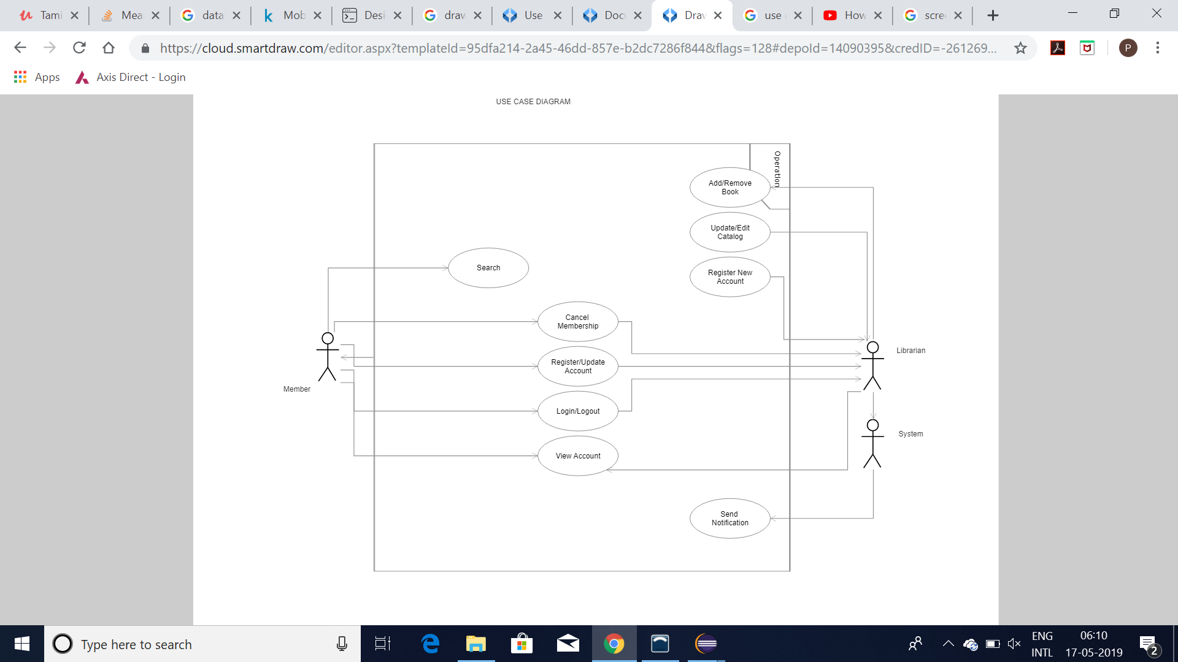

**CLASS DIAGRAM**

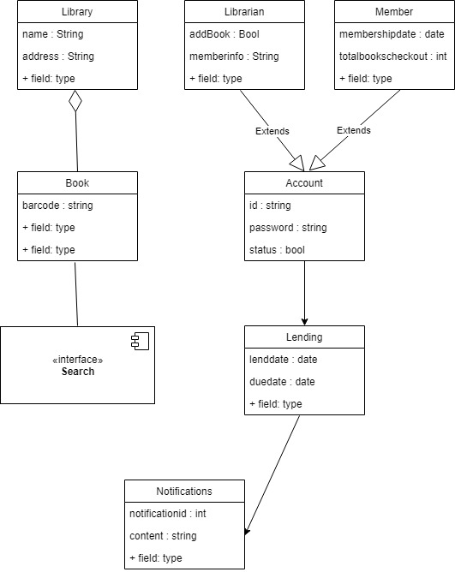

**ACTIVITY DIAGRAM**

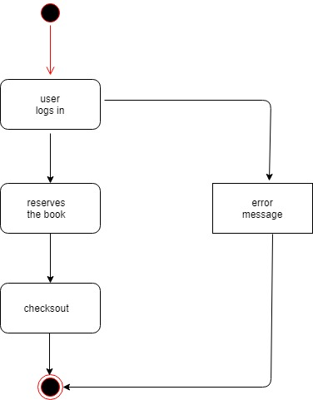

**Developed**

* The Application is fully functional
* Performs all the tasks

**Testing**

* Couldn’t search the database properly
* Couldn’t display the non-issued books separately

**SCREENSHOTS**

**Login Page**

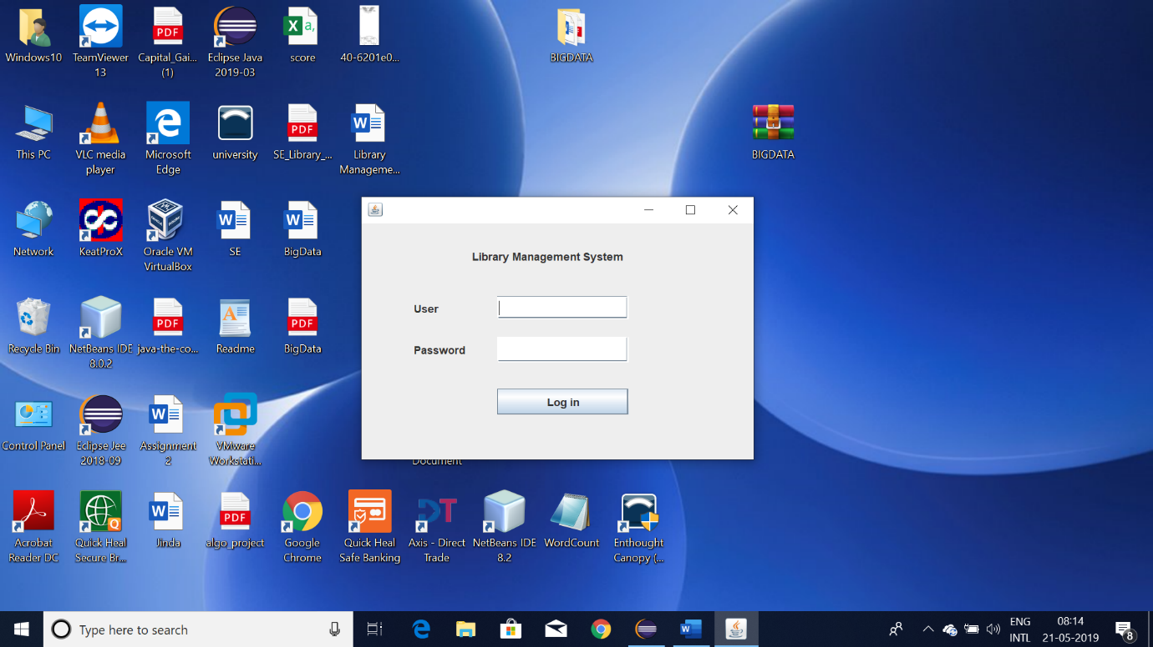

**Librarian Login ID: admin**

**Password: admin**

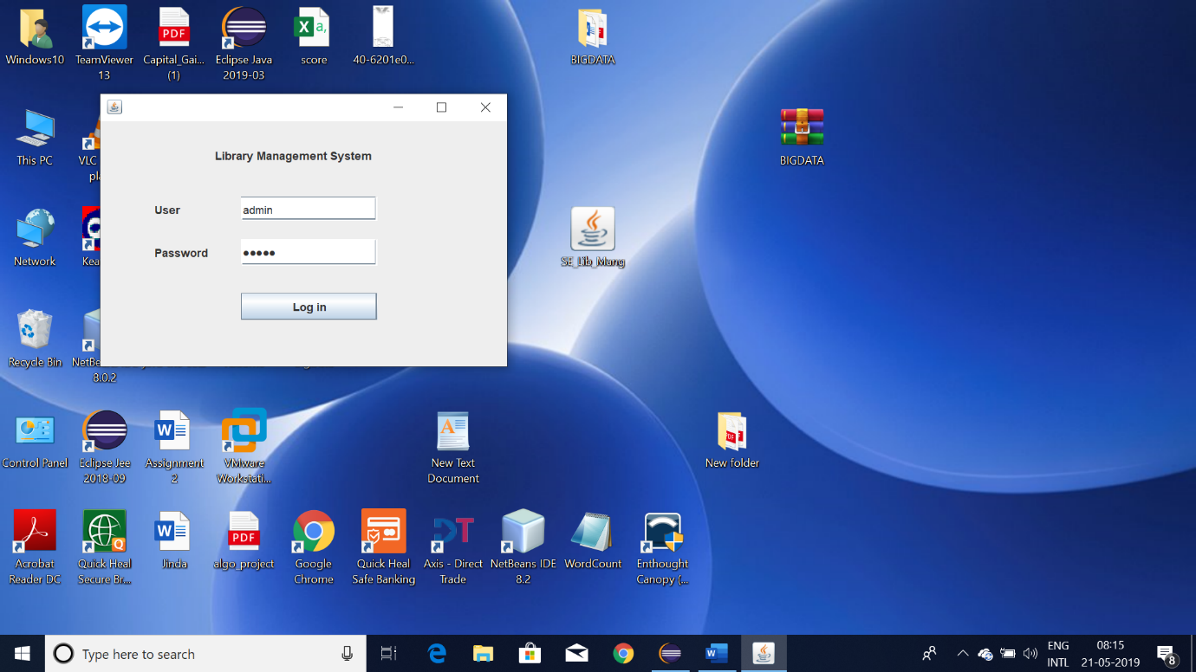

**Librarian Home Page**

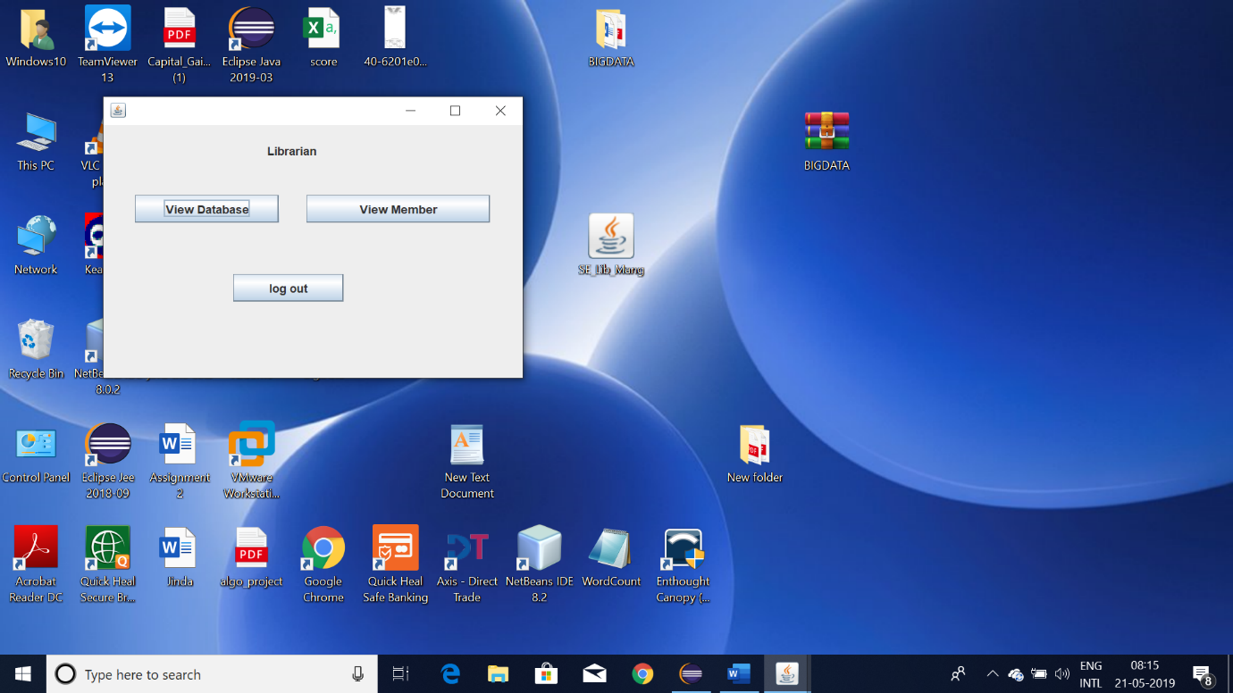

**Librarian Database view**

**Can add, edit, delete database**

**Can see which books are issued or are not**

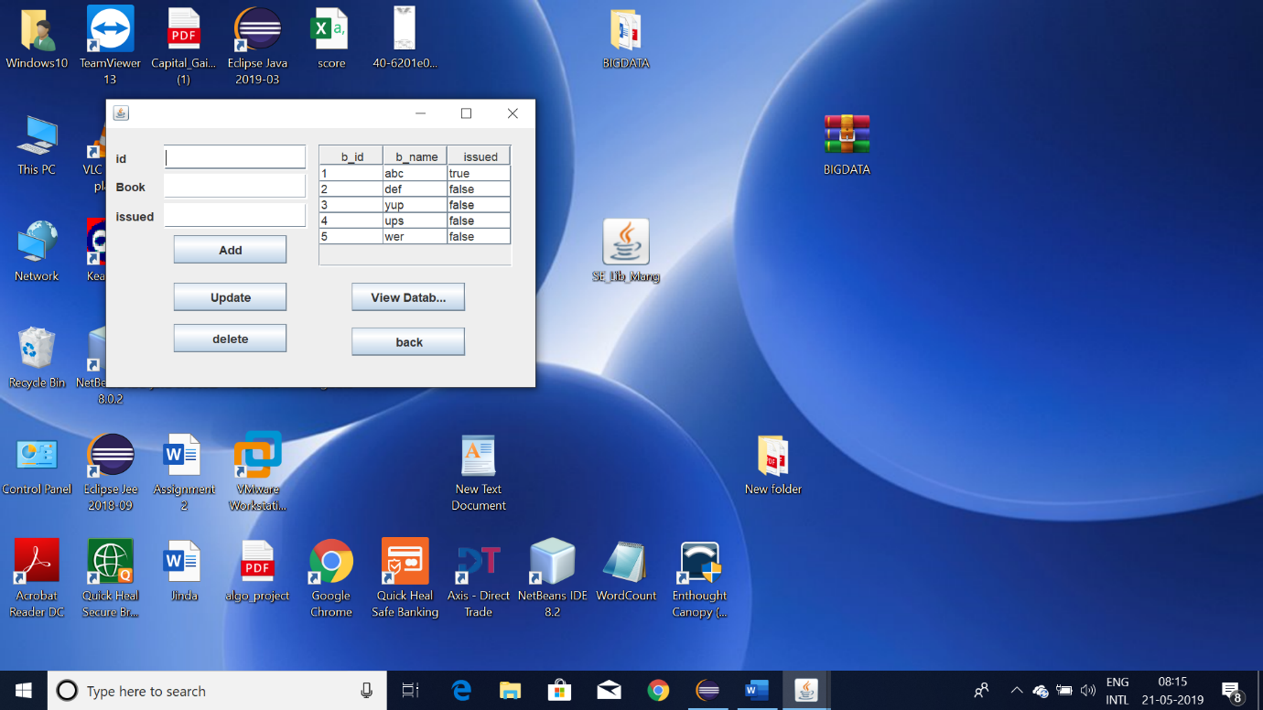

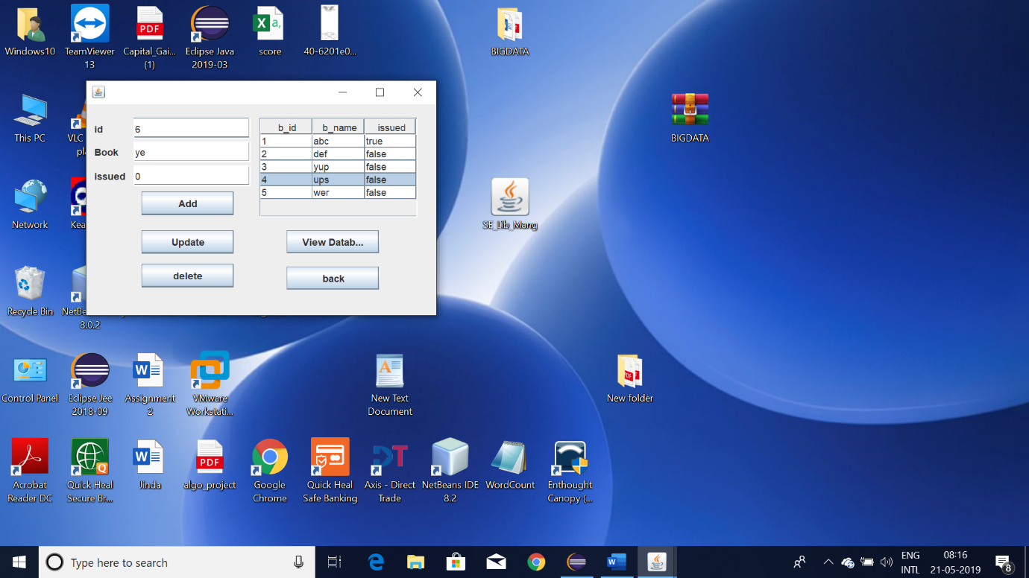

**Librarian’s Member page**

**Can add, edit, delete member**

**Can see how many books borrowed by member**

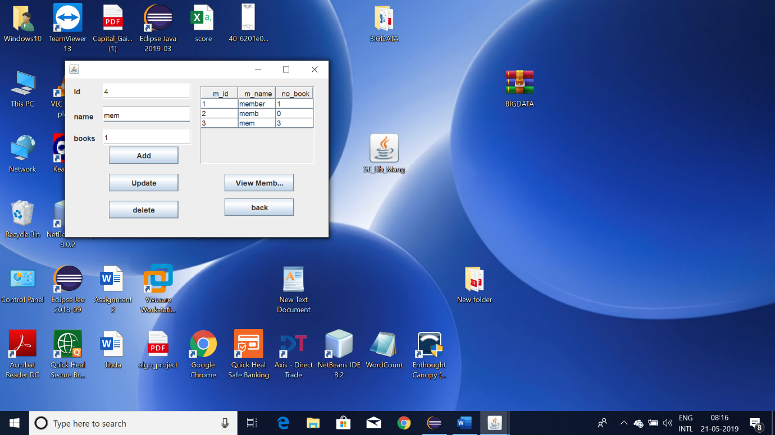

**Logged out   
  
Logged In as Member**

**Member id = member**

**Password = member**

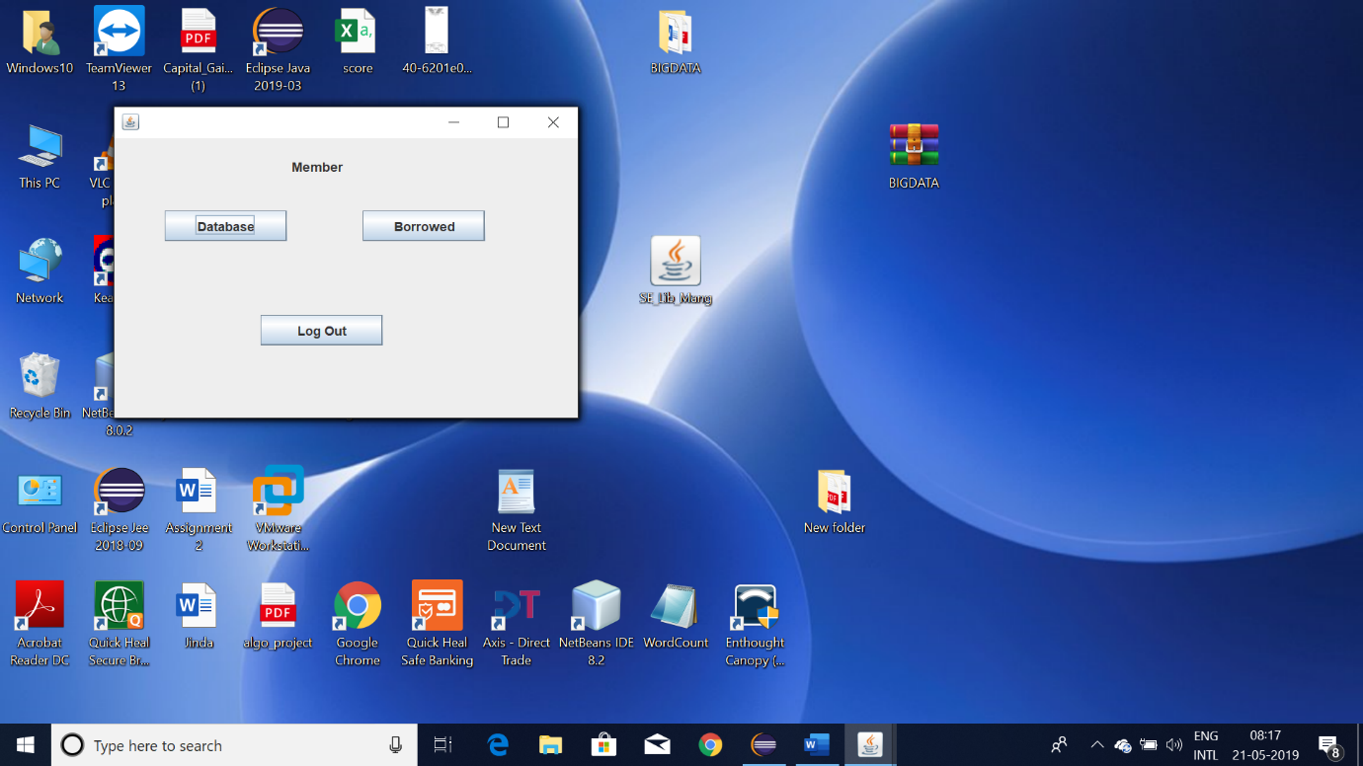

**Member can view library database**

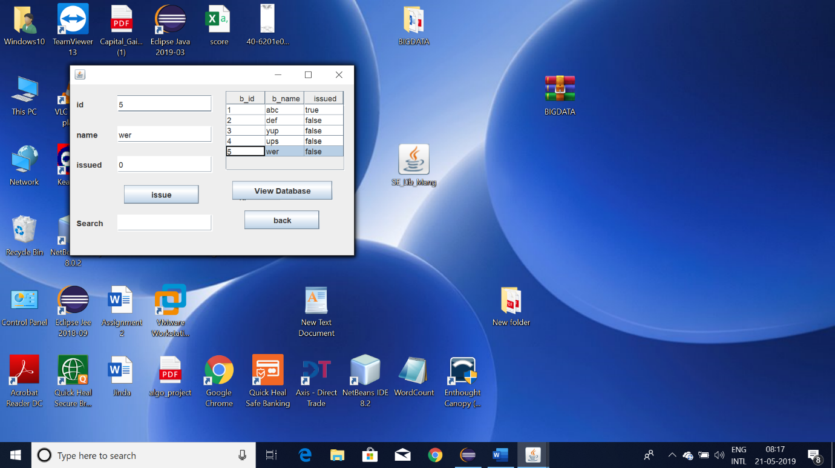

**Member can see the number of books issued**

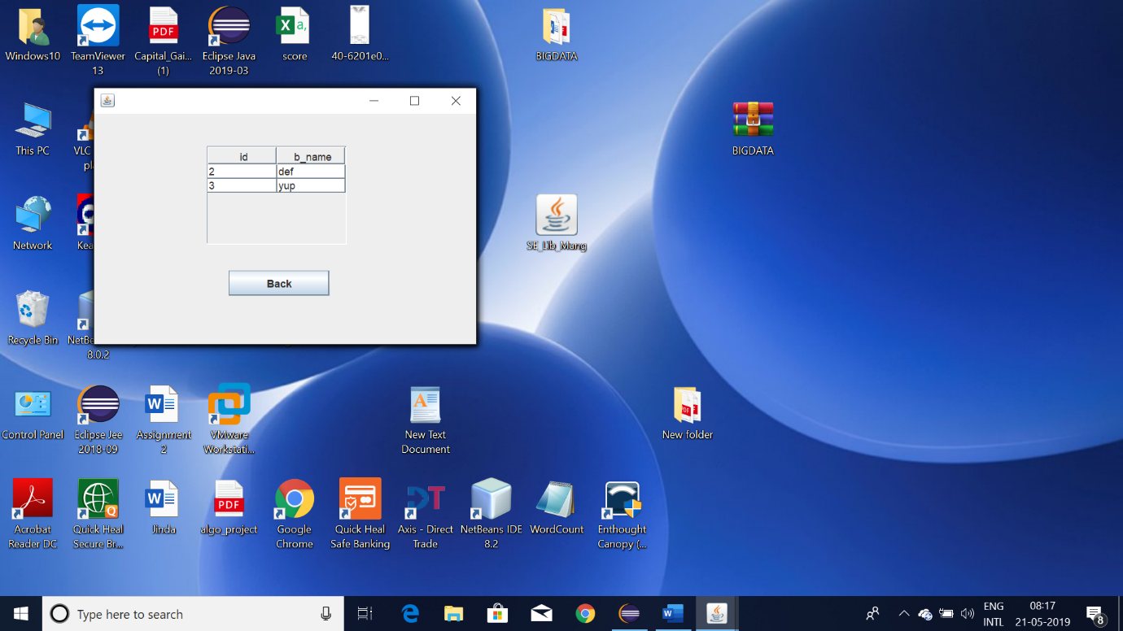

**CONCLUSION**

In conclusion, from proper analysis and assessment of the designed system it can be safely concluded that the system is an efficient, usable and reliable Library Management System.